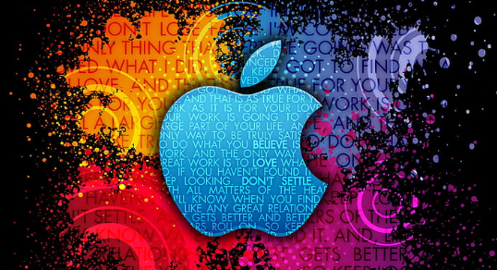**IREVOLUTION : A DATA – DRIVEN EXPLORATION OF APPLE’S IPHONE IMPACT IN INDIA.**

INTRODUCTION**:**

* **The Apple iphone is a line of smartphones designed and marketed by Apple.**
* **A technology company founded by STEVE JOBS, STEVE WOZNAIK, and RONALD WAYNE.**
* **The iphone was first introduced on January 9,2007, by STEVE JOBS, and it has since become one of the most iconic and popular smartphones in the world.**

**Overview:**

The iphone is a smartphone made by Apple that combines a computer, ipod, digital camera and cellular phone into one device with a touchscreen interface**.**

PURPOSE**:**

**The smartphones produced by Apple, combining mobile telephone, digitalcamera, music player, and personal computing technologies.**

**PROJECT FLOW:**

* **Annual revenue**
* **Apple products**
* **Country – wise share**
* **Flipkart smartphone**
* **Market penetration**
* **Model share**
* **Quartely – share**

**EMPATHY MAP:**

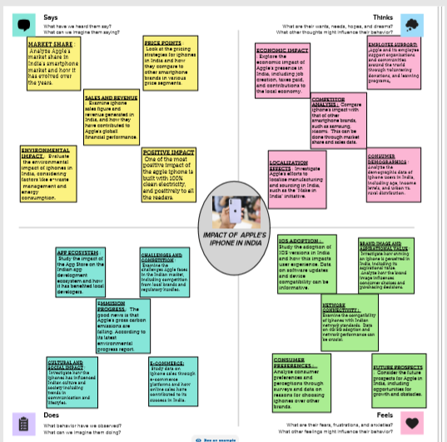

**BRAINSTROMING MAP:**

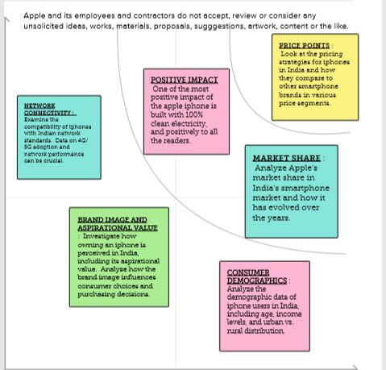

DATA PRESENTATION:

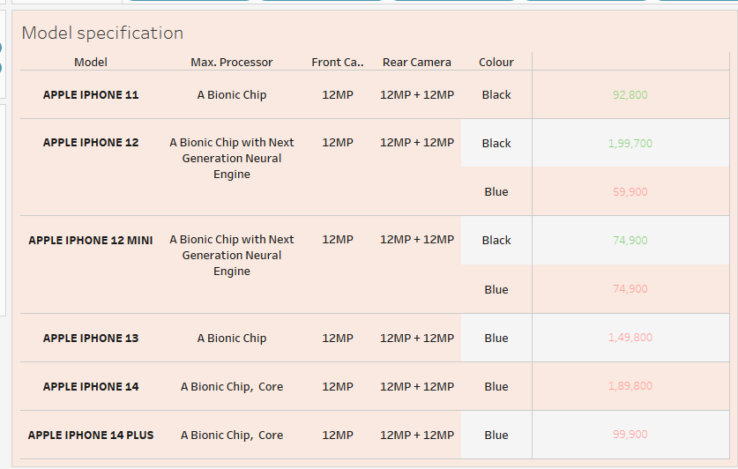

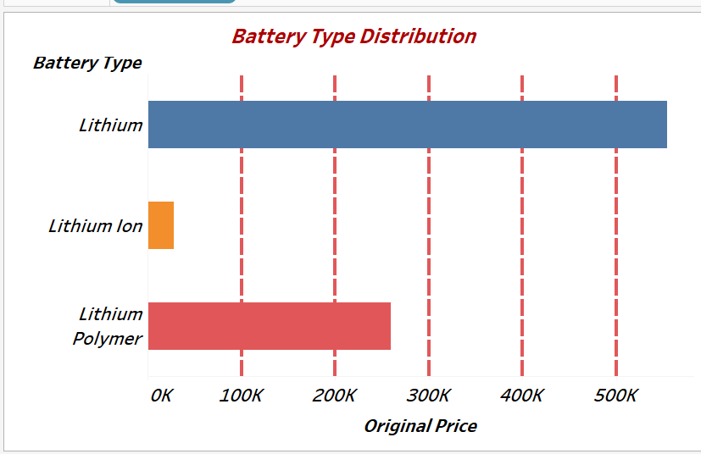

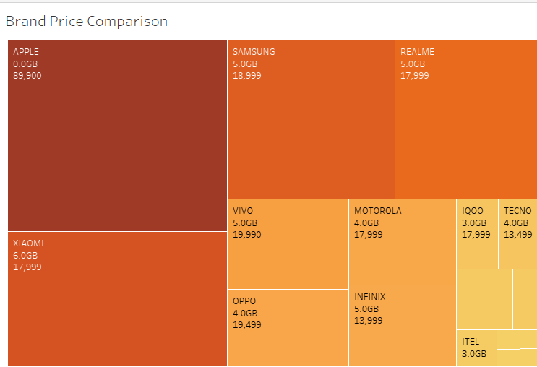

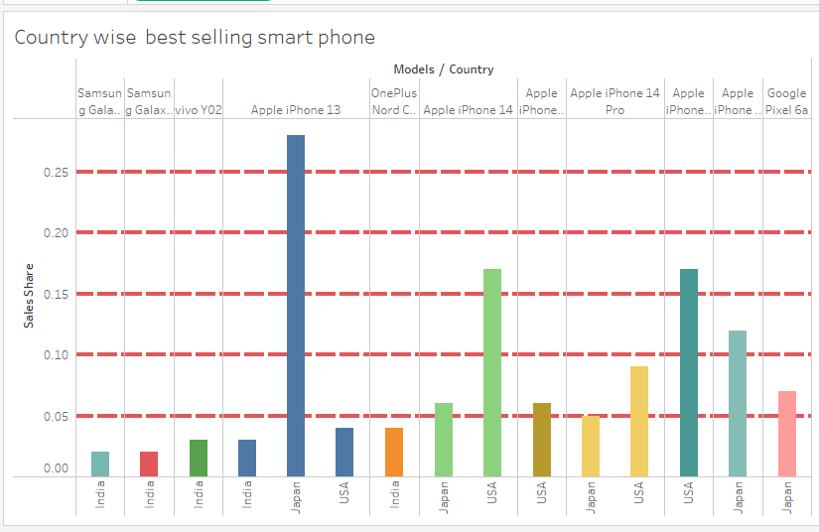

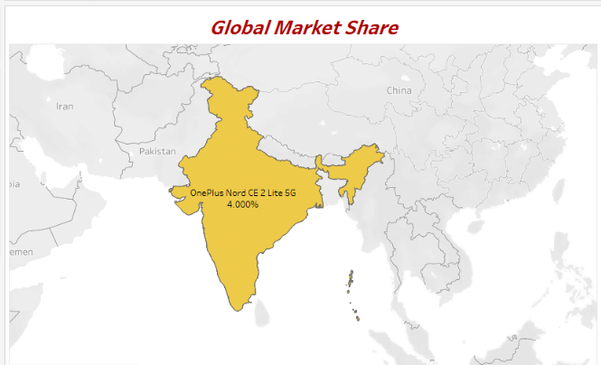

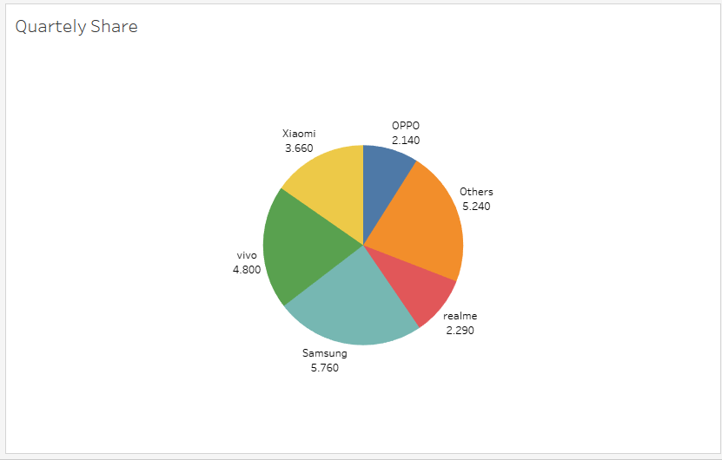

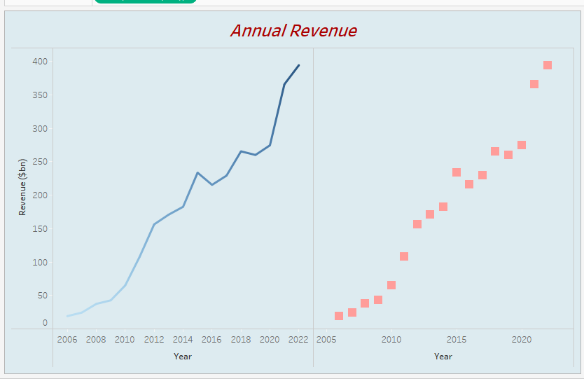

**DASHBOARD**

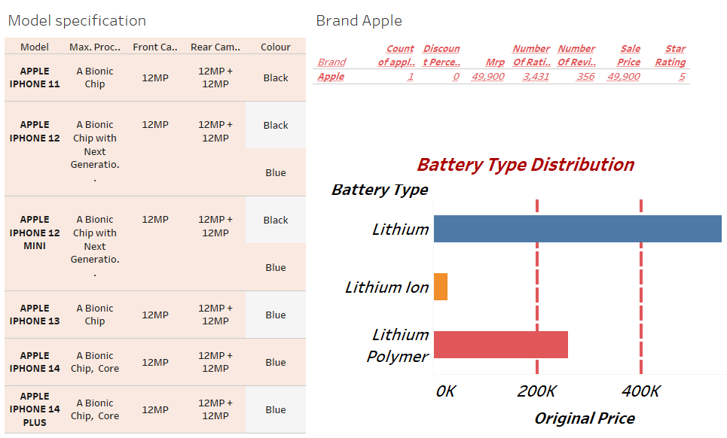

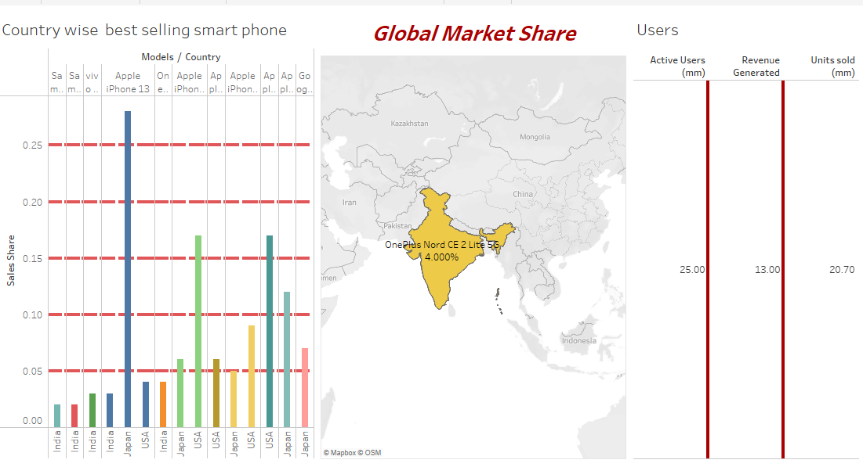

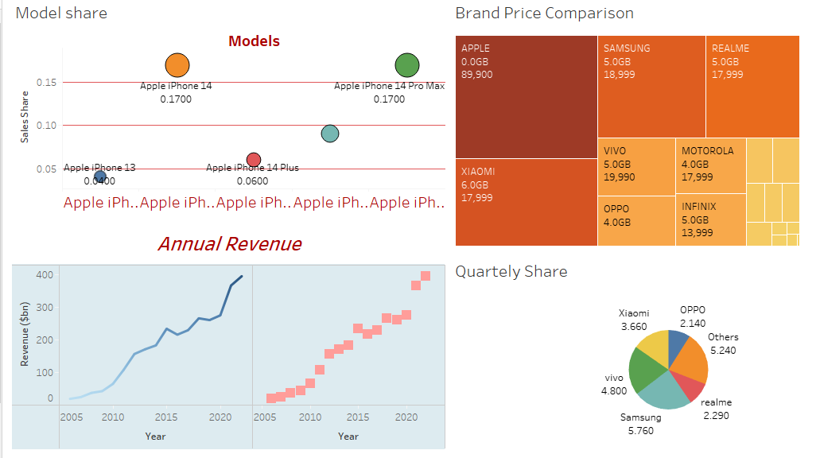

**Data visualization:**

